**HARSHA V N**

**1BM20CS406﻿**

**Hadoop Basic Commands**

**1. mkdir**

**Hadoop HDFS mkdir Command Usage**

**mkdir**

**Hadoop HDFS mkdir Command Example**

**hdfs dfs -mkdir /abc**

**Hadoop HDFS mkdir Command Description**

**This HDFS command takes path URI’s as an argument and creates directories.**

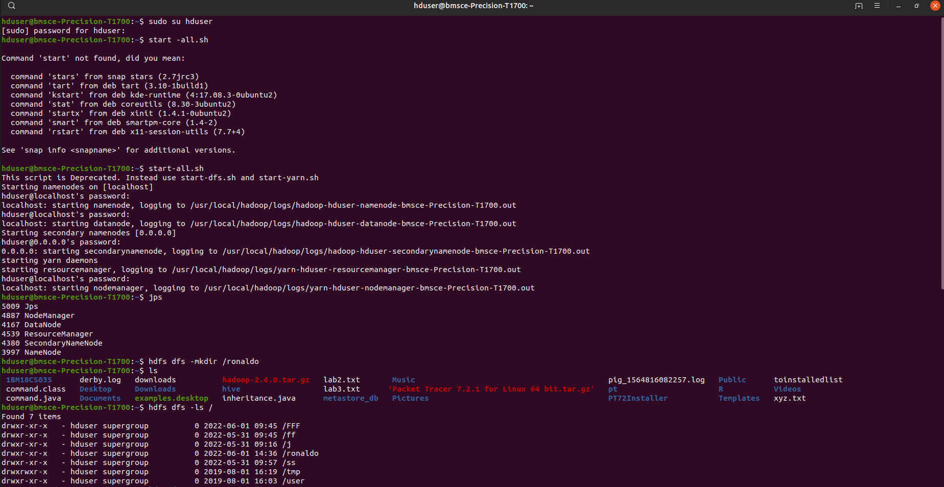

**2. ls**

**Hadoop HDFS ls Command Usage**

**ls**

**Hadoop HDFS ls Command Example**

**hadoop fs -ls /**

**Hadoop HDFS ls Commnad Description**

**This Hadoop HDFS ls command displays a list of the contents of a directory specified by path provided by the user, showing the names, permissions, owner, size and modification date for each entry.**

**3. put**

**Hadoop HDFS put Command Usage**

**put**

**Hadoop HDFS put Command Example**

**hdfs dfs -put /home/hduser/Desktop/Welcome.txt /abc/WC.txt**

**Hadoop**

**HDFS put Command Description**

**This hadoop basic command copies the file or directory from the local file system to the destination within the DFS.**

**Display the contents of the file WC.txt**

**hdfs dfs -cat /abc/WC.txt**

**4. copyFromLocal**

**Hadoop HDFS copyFromLocal Command Usage**

**copyFromLocal**

**Hadoop HDFS copyFromLocal Command Example**

**hdfs dfs -put /home/hduser/Desktop/Welcome.txt /abc/WC.txt**

**Hadoop HDFS copyFromLocal Command Description**

**This hadoop shell command is similar to put command, but the source is restricted to a local file reference.**

**Display the contents of the file WC2.txt**

**hdfs dfs -cat /abc/WC2.txt**

**5. get**

**Hadoop HDFS get Command Usage**

**get [-crc]**

**i.Hadoop HDFS get Command Example**

**hdfs dfs -get /abc/WC.txt /home/hduser/Downloads/WWC.txt**

**This HDFS fs command copies the file or directory in HDFS identified by the source to the local file system path identified by local destination.**

**ii.Hadoop HDFS get Command Example**

**hdfs dfs -getmerge /abc/WC.txt /abc/WC2.txt /home/hduser/Desktop/Merge.txt**

**This HDFS basic command retrieves all files that match to the source path entered by the user in HDFS, and creates a copy of them to one single, merged file in the local file system identified by local destination.**

**iii. Hadoop HDFS get Command Example**

**hadoop fs -getfacl /abc/**

**This Apache Hadoop command shows the Access Control Lists (ACLs) of files and directories.**

**6. copyToLocal**

**Hadoop HDFS copyToLocal Command Usage**

**copyToLocal**

**Hadoop HDFS copyToLocal Command Example**

**hdfs dfs -copyToLocal /abc/WC.txt /home/hduser/Desktop**

**Similar to get command, only the difference is that in this the destination is restricted to a local file reference.**

**7. cat**

**Hadoop HDFS cat Command Usage**

**cat**

**Hadoop HDFS cat Command Example**

**hdfs dfs -cat /abc/WC.txt**

**This Hadoop fs shell command displays the contents of the filename on console or stdout.**

**8. mv**

**Hadoop HDFS mv Command Usage**

**mv**

**Hadoop HDFS mv Command Example**

**hadoop fs -mv /abc /FFF**

**hadoop fs -ls /FFF**

**This basic HDFS command moves the file or directory indicated by the source to destination, within HDFS.**

**9. cp**

**Hadoop HDFS cp Command Usage**

**cp**

**Hadoop HDFS cp Command Example**

**hadoop fs -cp /CSE/ /LLL**

**hadoop fs -ls /LLL**

**The cp command copies a file from one directory to another directory within the HDFS.**

